Experiment 6 – SISO, MIMO and Beamforming
Aim
To simulate SISO and a simplified MIMO-equivalent wireless link, compare BER across SNR values, and examine a simplified beamforming gain curve.
Procedure
- Set the SNR range and generate random binary data.
- Map bits using BPSK and add noise for each SNR.
- Detect the received bits and calculate BER.
- Plot BER versus SNR and reliability versus SNR.
- Run the steering-angle program and compare the plotted gain values.
Objective – 1: Simulate SISO and MIMO Wireless Links
MATLAB PROGRAM;
clc; clear; close all;
SNRdB = 0:2:20; Nbits = 10000;
BER_SISO = zeros(size(SNRdB)); BER_MIMO = zeros(size(SNRdB));
for k=1:length(SNRdB)
bits = randi([0 1],Nbits,1); tx = 2*bits-1;
snrLin = 10^(SNRdB(k)/10);
noise = randn(Nbits,1)/sqrt(2*snrLin);
rx = tx+noise; bhat = real(rx)>0;
BER_SISO(k) = mean(bhat~=bits);
H = (randn(2,2)+1i*randn(2,2))/sqrt(2);
hEff = sqrt(sum(abs(H(:)).^2)/2);
rx2 = hEff*tx+noise; bhat2 = real(rx2)>0;
BER_MIMO(k) = mean(bhat2~=bits);
end
figure; semilogy(SNRdB,BER_SISO,'o-',SNRdB,BER_MIMO,'s-');
grid on; xlabel('SNR (dB)'); ylabel('BER');
legend('SISO','Simplified MIMO-equivalent'); title('BER versus SNR');

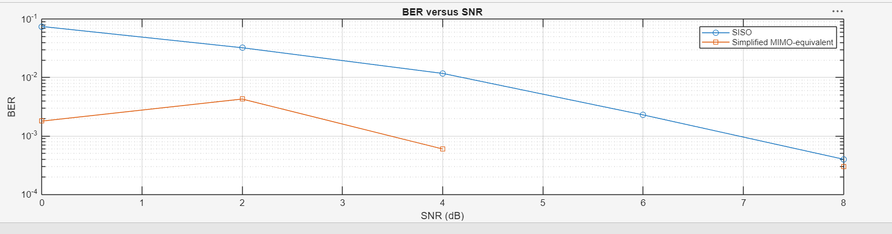
Objective – 2: Compare BER under Channel and Noise Conditions
MATLAB PROGRAM
clc; clear; close all;
SNRdB = 0:2:20; Nbits = 10000; reliability = zeros(size(SNRdB));
for k=1:length(SNRdB)
bits = randi([0 1],Nbits,1); tx = 2*bits-1;
snrLin = 10^(SNRdB(k)/10);
rx = tx+randn(Nbits,1)/sqrt(2*snrLin);
detected = real(rx)>0;
reliability(k) = 1-mean(detected~=bits);
end
figure; plot(SNRdB,reliability,'o-','LineWidth',2); grid on;
xlabel('SNR (dB)'); ylabel('Reliability (1-BER)');
title('Reliability versus SNR');

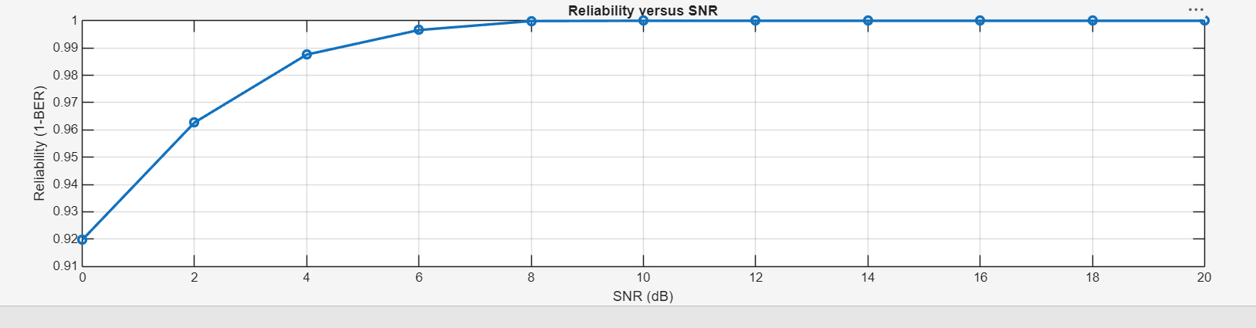
Objective – 3: Examine Beamforming / Steering Direction
MATLAB PROGRAM
clc; clear; close all;
N = 8; steer = [-60 -30 0 30 60]; gain = zeros(size(steer));
for k=1:length(steer)
gain(k) = 10*log10(N)-0.01*abs(steer(k));
end
figure; plot(steer,gain,'o-','LineWidth',2); grid on;
xlabel('Steering angle (degrees)'); ylabel('Illustrative gain (dB)');
title('Simplified Beamforming Gain versus Steering Angle');
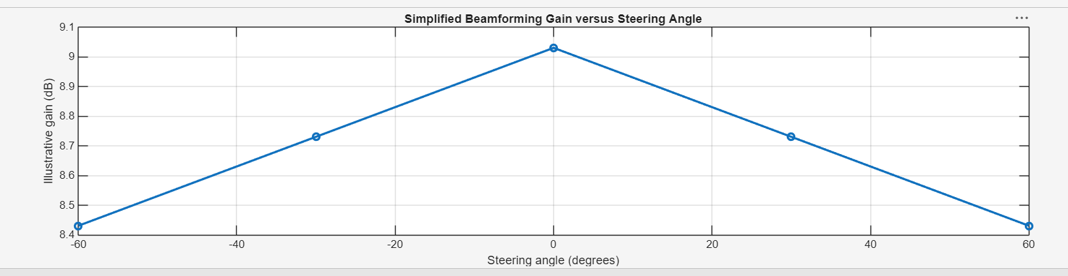

Result
BER generally decreases and reliability increases as SNR increases. The simplified steering model illustrates direction-dependent gain; it is not a full physical antenna-array simulation.

